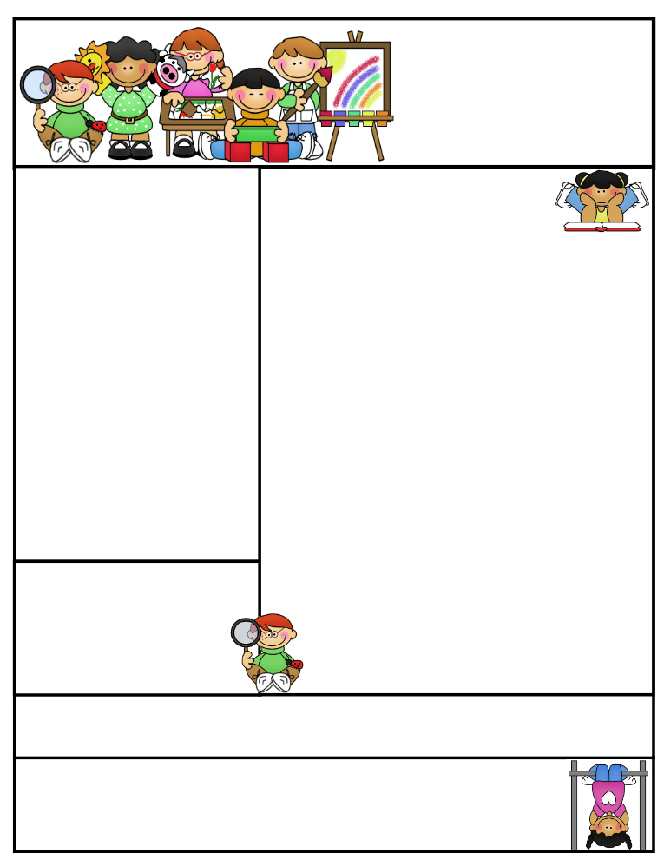
Miss Morey’s Class
Newsletter
March 9, 2015
What We’re Learning
E.L.A: Students can…
- identify the theme and main idea of a text
- determine the author’s purpose for writing (persuasive, inform, entertain)
- explain what persuasive writing is and why a author would write to persuade someone
- write an essay citing evidence of why they are lucky in their life
Math: Students can…
- describe solution strategies for solving fraction number stories
- identify the value of digits in decimals
- read, write and model fractions
- find equivalent names for fractions
- compare and order fractions
Spelling: Students can…
- spell high frequency words
- apply their knowledge of spelling to their everyday writing
Social Studies: Students can use…
    - explain what valuable resources come from the rainforest that are useful in our lives
    - identify and explain the different layers of a tropical rainforest
    - identify what animals live in each layer of the rainforest

Important Dates:
3/10 Bowling Field Trip
3/12 Chorus Concert (starts at 7:00, students asked to be here by 6:30)
3/20 Staff Development Day (no school for students)

Birthdays:
Happy Birthday Zachary on 3/11!
Kristen Morey
Fabius –Pompey Elementary School
kmorey@fabius.cnyric.org

“If you want to sing, sing out. And if you want to be free, be free.” *Remember our 3rd grade chorus concert this week!*
Created by Ashley Magee Graphics © ThistleGirlDesigns.com
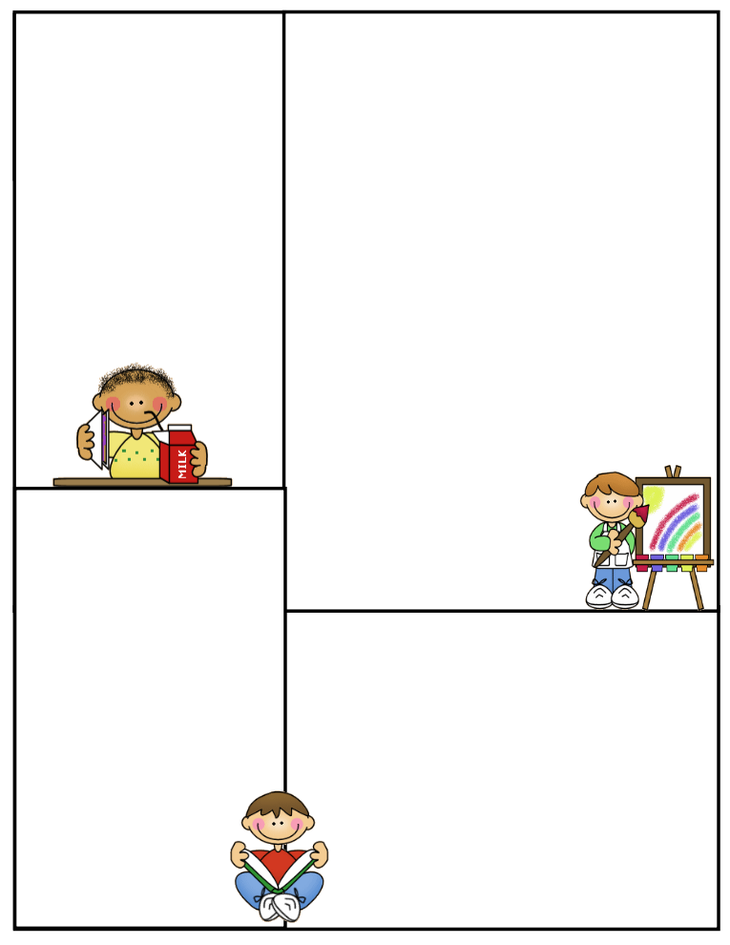
Bowling Trip
A gentle reminder to send in three dollars if your child is eating lunch at Green Lakes Lanes tomorrow if you have not already done so. We will not have time to call parents to drop it off tomorrow prior to us leaving if forgotten. Students need to wear boots to and from Green Lakes Lane and have clean sneakers to wear inside the facility. Approved chaperones need to be at Green Lakes Lane at 8:30 with their own transportation. Thank you! ☺

Spelling Words:
berry cherry happy
merry puppy bunny
funny hurry muddy
sorry carry furry
jelly pretty worry
HFW (high frequency words):
family later
turn move
face door
Positive Praise
Students have been working so hard on their persuasive letters to parents for a new pet. Our class used some very convincing words and terminology. I hope you will have a chance to see your child’s hard work at Open House, on Thursday, March 19th at 6:30-8:00. We also hope to see you at our chorus concert!
Parent Tip:
Students have been working on identifying the topic, main idea and supporting details of what they read. This can be a difficult task. You can help your child when reading at home. Below are some strategies.
1) To find the topic, prompt your child with, “This paragraph/article is about_____.” They should use 1 or 2 words to complete the sentence. Remind them that the topic is often found in the title and/or first or last sentence. Ex.) ice cream sundaes
2) To identify the main idea, have your child remind themselves of what the topic was. Then have them ask themselves, “What does this paragraph tell me about the topic? Ex.) What does this paragraph tell me about ice cream sundaes?” The answer to the question is the main idea. Ex.) Ice cream sundaes are made delicious by ingredients.
3) To find supporting details, have your child use the main idea and ask, “What specific information supports the main idea? Ex.) Ice cream sundae ingredients include ice cream, sauce and toppings.

Newsletter Template
Customize the newsletter template to meet your classroom needs. Click inside a box to type your information. Change the boxes to whatever you’d like to include!

Visit my blog for more freebies and lesson ideas:
http://firstgradebrain.blogspot.com

Visit my TeachersPayTeachers store for more products:
http://www.teacherspayteachers.com/Store/Mrs-Magee/Products

