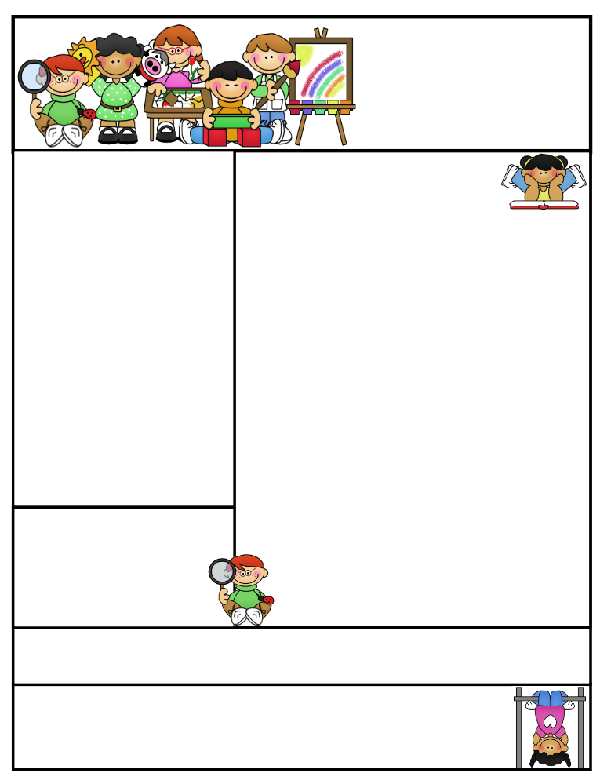
Miss Morey’s Class
Newsletter
March 30, 2015
What We’re Learning
E.L.A: Students can…
- Compare and contrast two fables
- Can identify the theme (message) of a story and use evidence to show how a character reveals the theme
- determine the author’s purpose for writing (persuasive, inform, entertain)
- can answer questions about a text by citing evidence from the reading
Math: Students can…
- identify and draw points, intersecting and parallel line segments, and lines, rays and right angles
- identify and describe plane and solid figures
- locate lines of symmetry and complete 2-D symmetric designs
- describe angle rotations
Spelling: Students can…
- apply their knowledge of spelling to their everyday writing
Social Studies: Students can use…
    - explain how animals and plants depend on one another for survival
    - identify what continent Brazil is located on
    - identify the capital, language, currency and government of Brazil

Important Dates:

4/3 Good Friday-No School
4/6-4/10 Spring Break-No School
Birthdays:

Kristen Morey
Fabius –Pompey Elementary School
kmorey@fabius.cnyric.org

“Strive for progress not perfection.”
Created by Ashley Magee Graphics © ThistleGirlDesigns.com
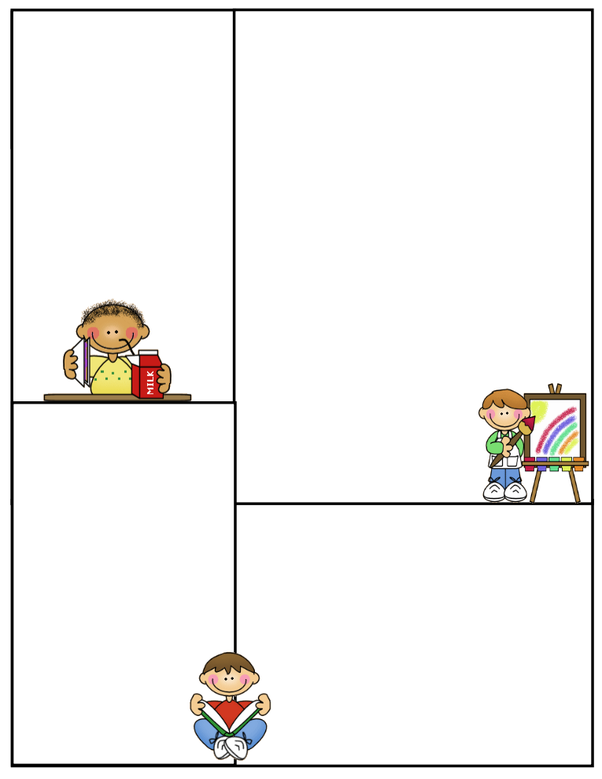
New York State Tests
Third graders will be taking the New York State Test upon our return from Spring Break. We have prepared for this test as a class and have discussed helpful tips for helping us succeed on “Game Day”. Below are some helpful tips for supporting your child at home.
Make sure your child has plenty of sleep and a healthy breakfast.
Some students will be nervous. Listen to them to determine why they are nervous; there might be a simple solution. Also, reassure them that it is for them, their teachers and their parents to know what they’ve mastered and what the adults need to further help them with. All we ask is that they try their best, so that we have a truthful picture to know how to help them and what they’re ready to learn next!
Encourage them to think of it as “Game Day” and their teacher and parents as their coaches. Remind them that they have practiced for this and now it’s time to show all of the many wonderful things they’ve learned! Be positive and calm, if you are, they more likely will be.
Remind them that if their focus drifts, they can kindly remind themselves of their goal, to finish their test to the best of their ability. If they get frustrated or anxious, they can take deep breaths and give themselves positive self talk, such as, “I can do it.”, “I’m almost to the touchdown.” etc.
Spelling Words:
There will not be spelling words or a math F.S.P. this week, due to preparing for the New York State Tests and the shortened week. Also, there will not be a late bus on Thursday, April 2nd, so students will not be staying after for clusters or small group E.L.A. support.
Positive Praise
Third graders have been doing a great job preparing for the New York State Tests after Spring Break. I’ve been very proud of their efforts and hope they enjoy their well deserved Spring Break. Due to the fact that the tests begin on Tuesday after break, please help your child get back into the routine of their school schedule, ensure that they get plenty of sleep and nutritious meals prior to Tuesday. Thank you for your continued support! ☺
J.A. Hoomis Writing Contest

Students this week will not have spelling words or a math F.S.P. I’m asking students to instead work on their writing for the J.A. Hoomis writing contest. Students will be working on this for homework at times throughout this week. Be on the lookout for more information sent home regarding this later this week!



Newsletter Template
Customize the newsletter template to meet your classroom needs. Click inside a box to type your information. Change the boxes to whatever you’d like to include!

Visit my blog for more freebies and lesson ideas:
http://firstgradebrain.blogspot.com

Visit my TeachersPayTeachers store for more products:
http://www.teacherspayteachers.com/Store/Mrs-Magee/Products

