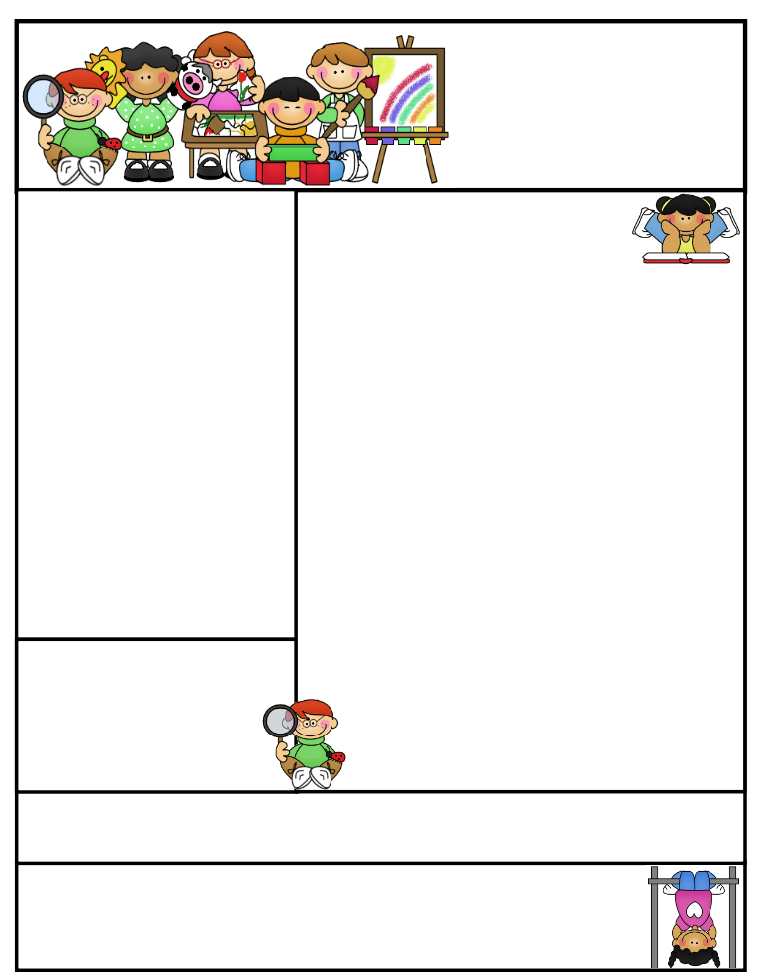
Miss Morey’s Class
Newsletter
March 23, 2015
What We’re Learning
E.L.A: Students can…
- Compare and contrast two fables
- Can identify the theme (message) of a story and use evidence to show how a character reveals the theme
- determine the author’s purpose for writing (persuasive, inform, entertain)
- can answer questions about a text by citing evidence from the reading
Math: Students can…
- review and master the concepts and skills we have been working on since September
- identify and draw points, intersecting and parallel line segments, lines, rays and right angles
- identify and describe plane and solid figures
- locate lines of symmetry and complete 2-D symmetric designs
Spelling: Students can…
- apply their knowledge of spelling to their everyday writing
Social Studies: Students can use…
    - explain how animals and plants depend on one another for survival
    - identify what continent Brazil is located on
    - identify the capital, language, currency and government of Brazil

Important Dates:

4/3 Good Friday-No School
4/6-4/10 Spring Break-No School
Birthdays:
Happy Birthday Saige on 3/28!
Kristen Morey
Fabius –Pompey Elementary School
kmorey@fabius.cnyric.org

Created by Ashley Magee Graphics © ThistleGirlDesigns.com
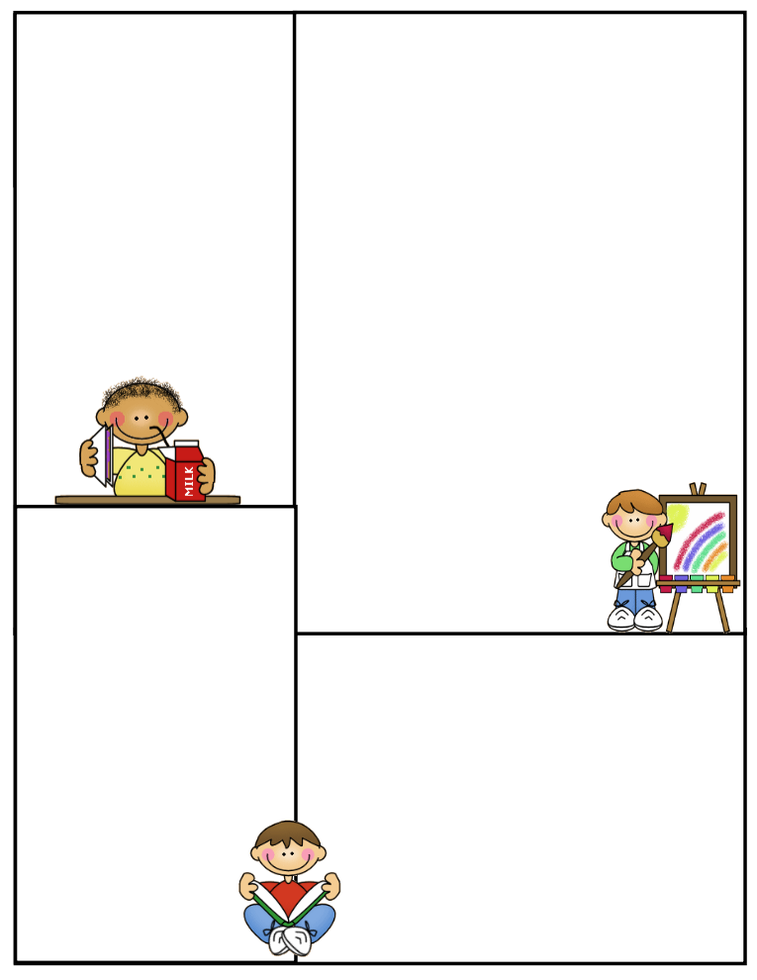
Thank you to all the families who came to Open House last Thursday. It was great to touch base with you. I also loved watching students’ excitement when showing their families their work. They have much to be proud of!
The Book Fair will be open from Monday, March 23 to Thursday, March 26. Our class visited it today and students filled out wish lists. If your child didn’t have a chance to purchase a book at Open House and you would like them to, they can purchase it at a convenient time in the school day.
Some students have been buying items at the school store during lunchtime for classmates. While students are trying to be kind to those classmates that they are buying for, it often leads to disagreements and hurt feelings from those who are excluded. The lunch monitors and I have spoken to students about this matter. Please reinforce the message at home, especially if you are aware that your child is purchasing things at the school store. Having the conversation with your child that they will only be buying items for themselves is very helpful. Thank you! ☺
Spelling Words:
digging planned
running sledding
swimming dropped
putting scrubbing
spotted tripped
hopped rubbed
sitting stopped
wrapping
HFW (high frequency words):
fish plants
living short black eat
Positive Praise
Students worked really hard in order to have their work done on a timely basis for Open House. They came together as a team and gave their level four effort in order to get everything done. Great job third graders!

Parent Tip:
Some students have been struggling on their math FSPs that are handed out on Mondays and are generally due on Fridays, unless it is a shortened week. I have noticed that some students are handing FSPS in that are not completed at times. I consider the FSPs to be extremely important because it gives students an opportunity to practice and master some of the most critical math concepts in third grade. Please make sure that your child is completing them in their entirety. It is okay if a student needs help with them; they can ask me for assistance or of their parents for four nights prior to handing them in. It’s not acceptable, however to not attempt them. Also, please continue to practice math facts at home (addition, subtraction, multiplication, division). They are the foundation for so many other concepts and students need to be fluent in them to be successful in third grade math and in the upcoming years. Thank you for your continued support at home of your child’s education.

Newsletter Template
Customize the newsletter template to meet your classroom needs. Click inside a box to type your information. Change the boxes to whatever you’d like to include!

Visit my blog for more freebies and lesson ideas:
http://firstgradebrain.blogspot.com

Visit my TeachersPayTeachers store for more products:
http://www.teacherspayteachers.com/Store/Mrs-Magee/Products

