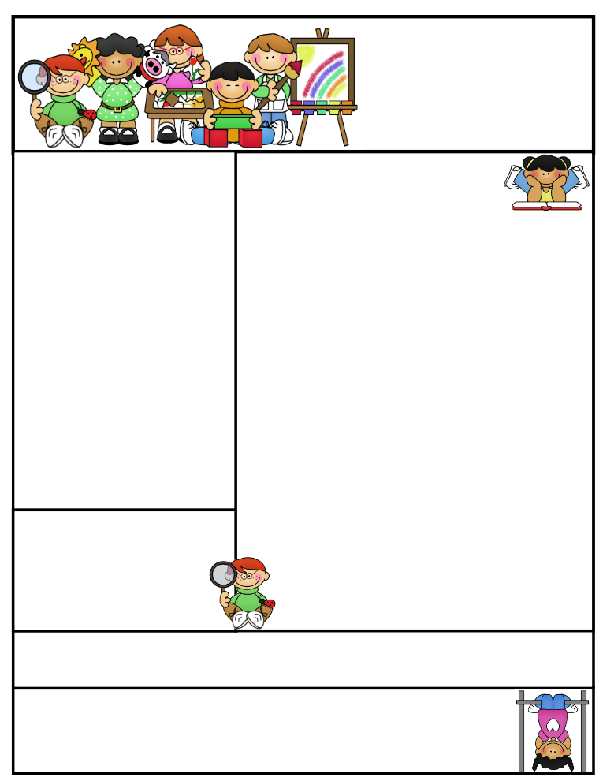
Miss Morey’s Class
Newsletter
March 2, 2015
What We’re Learning
E.L.A: Students can…
- identify the theme and main idea of a text
- describe a character’s traits
- determine the author’s purpose for writing (persuasive, inform, entertain)
- explain what persuasive writing is and why a author would write to persuade someone
- write a persuasive piece with guidance
Math: Students can…
- read and write fractions
- represent, identify and generate equivalent fractions using manipulatives and drawings
- compare fractions to ½
- use an area model to compare fractions
- identify patterns and relationships between numerators and denominators of fractions
- shade fractional parts of regions to represent fractions greater than 1
Spelling: Students can…
- spell high frequency words
- apply their knowledge of spelling to their everyday writing
Social Studies: Students can use…
    - list animals that live within the Amazon Rainforest
    - identify reasons the Amazon Rainforest is in trouble

Important Dates:
3/10 Bowling Field Trip
3/12 Chorus Concert
3/20 Staff Development Day

Birthdays:

Kristen Morey
Fabius –Pompey Elementary School
kmorey@fabius.cnyric.org

“Don’t give up. I believe in you all. A person’s a person, no matter how small.” –Dr. Seuss
Created by Ashley Magee Graphics © ThistleGirlDesigns.com
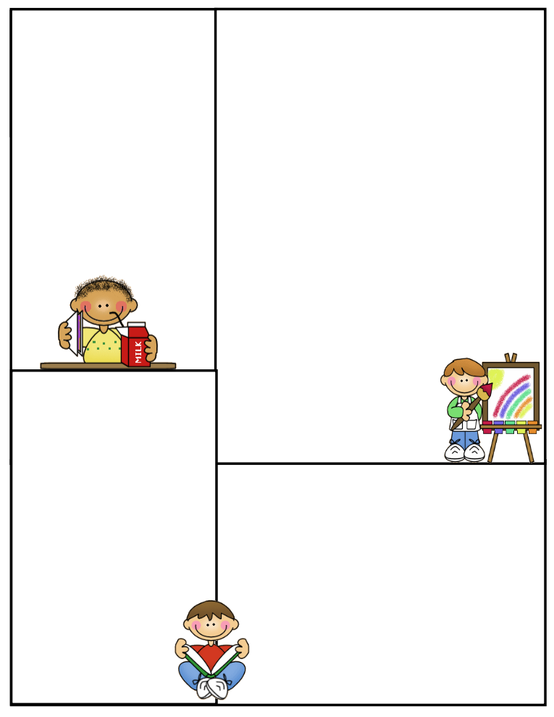
A gentle reminder to those who have not yet returned their child’s permission slip for our field trip on March 10th, to please do so as soon as possible. Thank you!
As part of our Dr. Seuss celebrations this week, students will be celebrating with reading a book in the gym on Friday and enjoy a slice of birthday cake. If your child would like to bring in a blanket on Friday for reading, they may do so.

Spelling Words:
supper happen letter
pepper kitten sudden
dinner cotton lesson
mitten bottom better
ladder ribbon
HFW (high frequency words):
didn’t morning
car upon
I’m body

Positive Praise
This week we are celebrating Dr. Seuss’s anniversary of his birthday and the many contributions he made to reading. This morning we had an assembly as an entire school to kick off Read Across America Week and to celebrate Dr. Seuss. We sang songs, watched a short video based on Dr. Seuss’s book Oh, The Places You’ll Go! and had a great start to our week. Our class did a great job of listening respectfully to the speaker and having a fun time, however making choices that followed T.K.N.S. Way to go third graders! ☺
Parent Tip:
Students have been working on identifying the topic, main idea and supporting details of what they read. This can be a difficult task. You can help your child when reading at home. Below are some strategies.
1) To find the topic, prompt your child with, “This paragraph/article is about_____.” They should use 1 or 2 words to complete the sentence. Remind them that the topic is often found in the title and/or first or last sentence. Ex.) ice cream sundaes
2) To identify the main idea, have your child remind themselves of what the topic was. Then have them ask themselves, “What does this paragraph tell me about the topic? Ex.) What does this paragraph tell me about ice cream sundaes?” The answer to the question is the main idea. Ex.) Ice cream sundaes are made delicious by ingredients.
3) To find supporting details, have your child use the main idea and ask, “What specific information supports the main idea? Ex.) Ice cream sundae ingredients include ice cream, sauce and toppings.

Newsletter Template
Customize the newsletter template to meet your classroom needs. Click inside a box to type your information. Change the boxes to whatever you’d like to include!

Visit my blog for more freebies and lesson ideas:
http://firstgradebrain.blogspot.com

Visit my TeachersPayTeachers store for more products:
http://www.teacherspayteachers.com/Store/Mrs-Magee/Products

