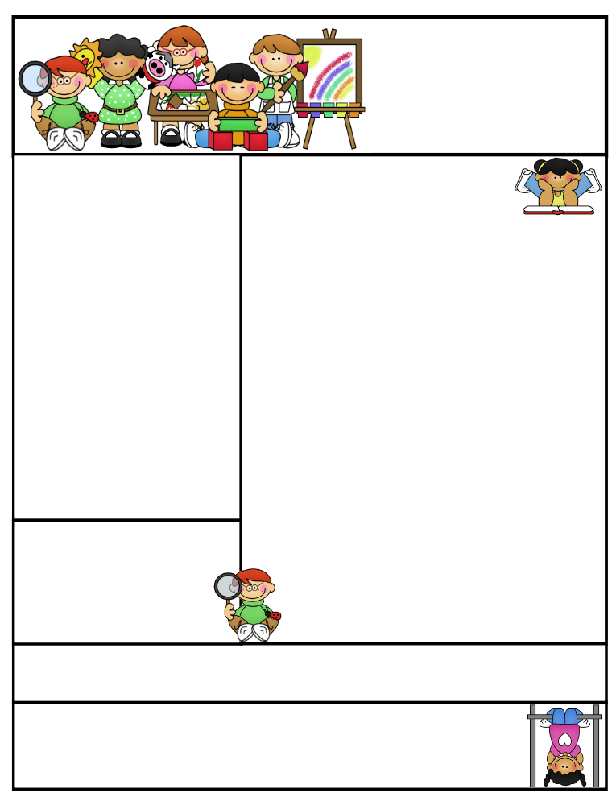
Miss Morey’s Class
Newsletter
March 16, 2015
What We’re Learning
E.L.A: Students can…
- Compare and contrast two fables
- Can identify the theme (message) of a story and use evidence to show how a character reveals the theme
- determine the author’s purpose for writing (persuasive, inform, entertain)
- write an essay citing evidence of why they are lucky in their life
Math: Students can…
- review and master the concepts and skills we have been working on since September
- represent and solve problems involving multiplication and division.
- solve problems involving the four operations, and identify and explain patterns in arithmetic
- use place value understanding and properties of operations to perform multi-digit arithmetic.
Spelling: Students can…
- apply their knowledge of spelling to their everyday writing
Social Studies: Students can use…
    - explain what valuable resources come from the rainforest that are useful in our lives
    - identify and explain the different layers of a tropical rainforest
    - identify what animals live in each layer of the rainforest

Important Dates:
3/19 Open House 6:30-8:00
3/20 Staff Development Day (no school for students)

Birthdays:

Kristen Morey
Fabius –Pompey Elementary School
kmorey@fabius.cnyric.org

Created by Ashley Magee Graphics © ThistleGirlDesigns.com
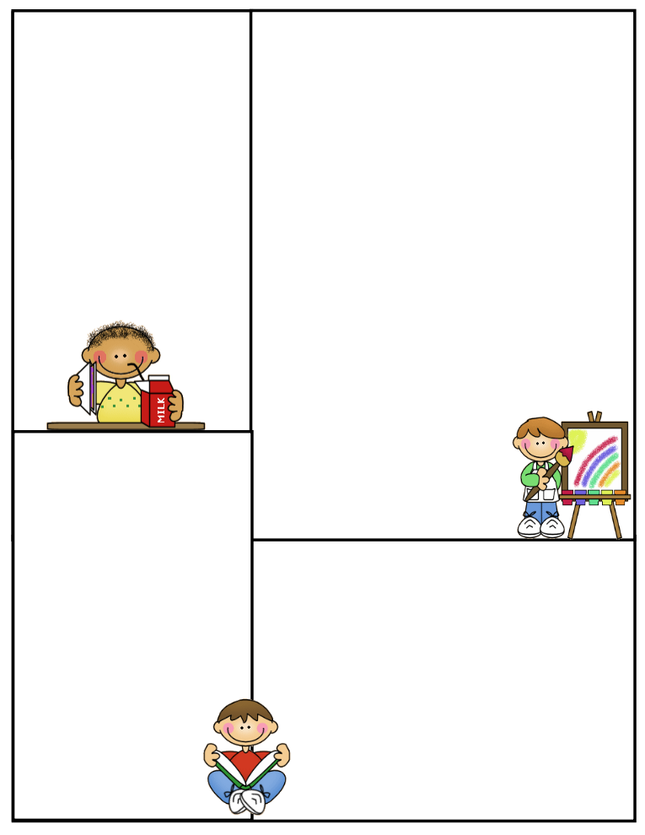
Bowling Trip
Open House is this Thursday, March 19th from 6:30-8:00. Students are so excited to show what they have been working on and to be “tour guides” for you through their daily school day. I hope you will be able to make it to see all that students have learned so far this year and their many wonderful pieces of work!
Also, the Book Fair will be open in the auditorium during Open House. Feel free to browse the many interesting books they have available! The Book Fair will be open from Monday, March 23 to Thursday, March 26. Our class will be visiting it on Monday, March 23rd from 1:30-2:00. Your child can also purchase a book then or during a convenient time on the days following.
Spelling Words:
coming skating taking
giving choosing
baking smiling
sliding changing
waving leaving hoping
trading having
HFW (high frequency words):
cut group
done true
half red
Positive Praise
Students have been hard at work writing persuasive letters to their parents for being able to get a pet, building Amazon Rainforests, making a book of advice for life for my brand new niece and writing essays of how they are lucky in life. We hope to see you at Open House, so that you can enjoy these many projects!
Also, congratulations to the third grade choir on their concert last week. The third grade class did an amazing job collaborating as a group, preparing and giving their best third grade effort, both during the concert for the entire school and for the community at night!
Parent Tip:
Some students have been struggling on their math FSPs that are handed out on Mondays and are generally due on Fridays, unless it is a shortened week. I have noticed that some students are handing FSPS in that are not completed at times. I consider the FSPs to be extremely important because it gives students an opportunity to practice and master some of the most critical math concepts in third grade. Please make sure that your child is completing them in their entirety. It is okay if a student needs help with them; they can ask me for assistance or of their parents for four nights prior to handing them in. It’s not acceptable, however to not attempt them. Also, please continue to practice math facts at home (addition, subtraction, multiplication, division). They are the foundation for so many other concepts and students need to be fluent in them to be successful in third grade math and in the upcoming years. Thank you for your continued support at home of your child’s education.

Newsletter Template
Customize the newsletter template to meet your classroom needs. Click inside a box to type your information. Change the boxes to whatever you’d like to include!

Visit my blog for more freebies and lesson ideas:
http://firstgradebrain.blogspot.com

Visit my TeachersPayTeachers store for more products:
http://www.teacherspayteachers.com/Store/Mrs-Magee/Products

