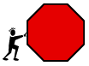 Artist
Read the book or chapter. Pick your favorite part of the story. Draw a picture that shows what is happening in the story. Write 2-3 sentences that tell about the event in the story.

________________________________________________________
________________________________________________________

 Connector
Read the book or chapter. As you read, think of something the story reminds you of in your own life. The connection could be a book, a TV show, or something you’ve done. Write about what the story made you think of and why it made you think of it.

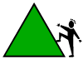 Discussion
Read the book or chapter. As you read, think of questions you could ask your group about the story. Remember to think of “fat” questions.
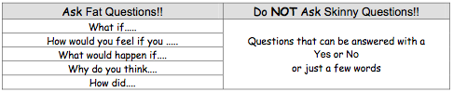
1.___________________________________________

2.__________________________________________

3.__________________________________________
____________________________________________

4.__________________________________________

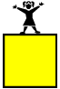 Storyteller
Read the story or chapter. As you read, you will identify the main characters and setting of the story. You will write a story summary and tell the main events in 4-5 sentences.

Main characters: _______________________________

Setting: _____________________________________

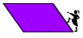 Words
Read the book or chapter and find three words that you do not know, words that are interesting, unusual, cool, or just funny. Write the words on this sheet and look them up in the dictionary. Write their meanings so you can tell your group.

Word # 1_________________________ page_______

Definition: ___________________________________
____________________________________________

Word # 2_________________________ page_______

Definition: ___________________________________
____________________________________________

Word # 3_________________________ page_______

Definition: ___________________________________
____________________________________________

By Joanne Griffin Clip art by Microsoft

