F-P Senior Athlete Spotlight!!!

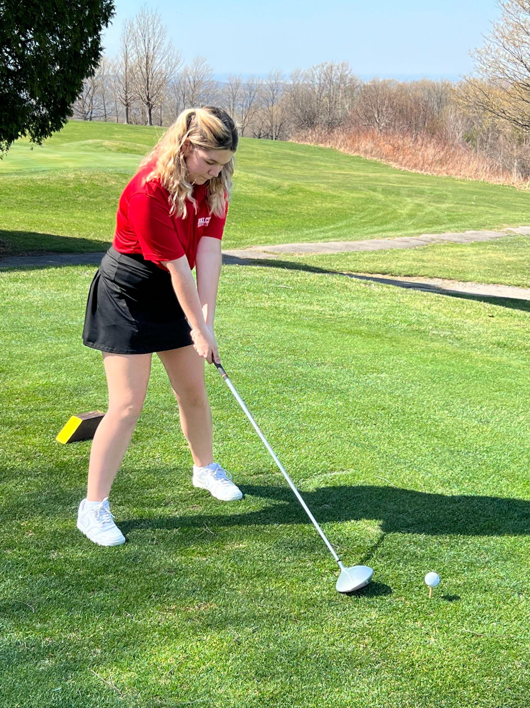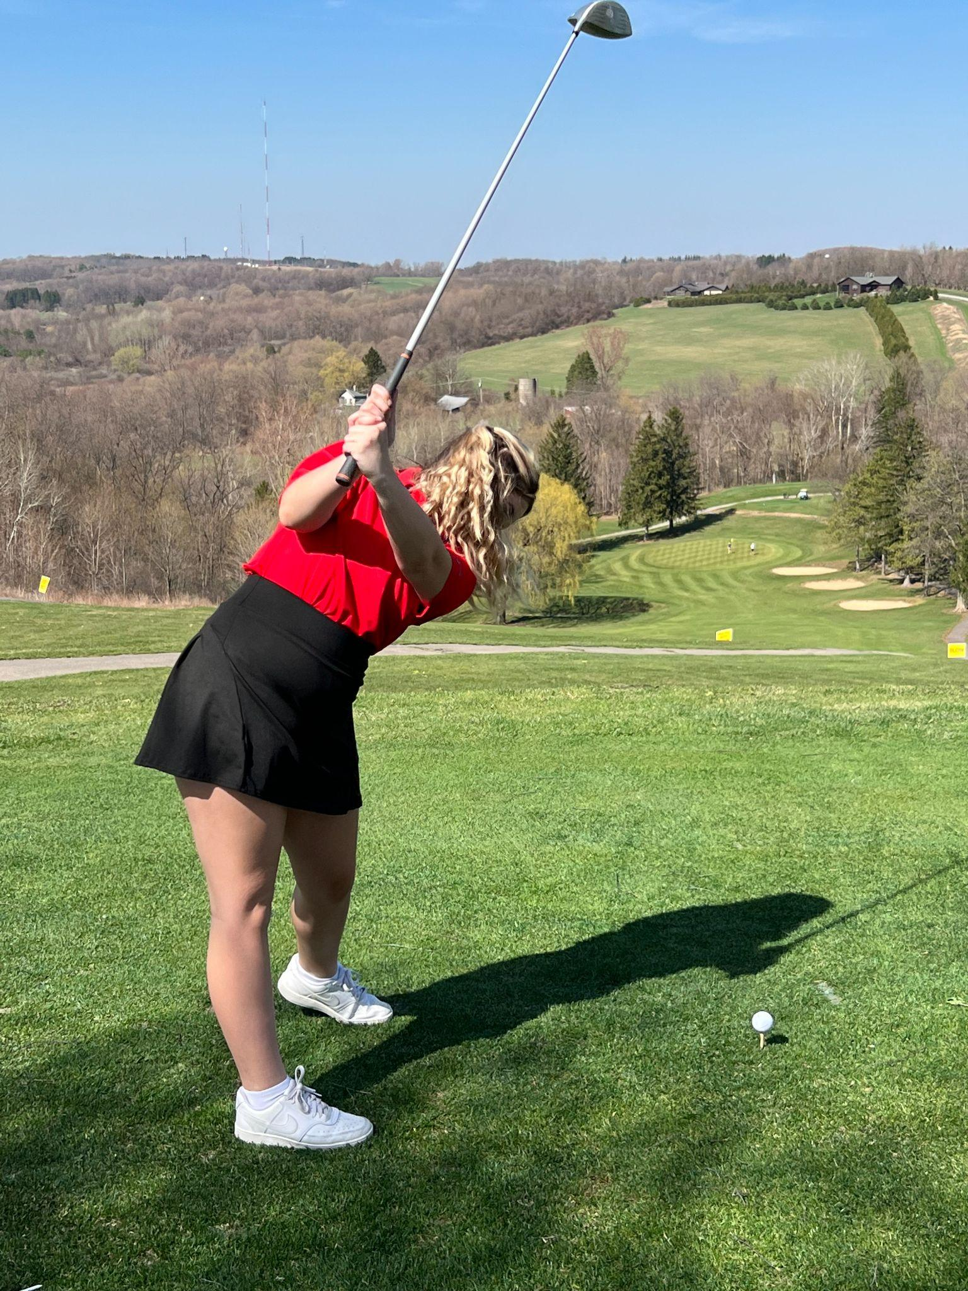
Athletes Name:Josslyn Wagner
Parent’s Guardian's Names:Meg Wagner
Were you parents graduates of FP and if so what year?Yes 1988
Favorite Sport Played:Golf
Played this sport since:Freshman year
Position played:----
Other athletic experiences:Soccer for ten years and softball for 3 years
Who are/are your biggest sports influences or inspirations?
Probably Marisa Trommel, she works so hard for both her sports and education and although she’s just a classmate of mine it really encourages me to put some effort in too.
Most respected opponent:I loved playing against Marcellus in golf because they’re players were all really nice and funny.
Favorite memory of your favorite sport and why:One of my first golf matches freshman year we went to Pulaski and it was cold so when we had finished golfing and were just waiting for our teammates to be done we sat inside the restaurant at the club and this random women had a dog came up to us put the little dog in my lap and said here watch him I was so confused and ten seconds later the dog jumped out of my lap and ran into the restaurant.
Most embarrassing moment:Teeing off in front of my teammates and the other team and just missing the ball completely.
Do you have any pre-game rituals or superstitions?Nope
What word best describes you?Supporting
What is your favorite food?Potatoes
Favorite quote or saying:“Always make the total effort, even if the odds are against you” - Arnold Palmer
Name a coach, player or person who has made a significant impact on your life:Coach Gorman
What are your college or future plans?Attend TC3 this fall for early childhood development
What is your career interest?Child care work
Where do you see yourself in 10 years?Probably married with a few kids.
What would be your inspirational quote to the future athletes here at Fabius-Pompey?“It’s not about whether you win or lose it’s about where you go to eat on the way home” - Stan Gorman

