September 2021

Dear Parents,

This week begins a brand new school year and I’d like to extend a warm welcome to you.
I have put together this brief handbook of information to help you and your child become familiar with my expectations and procedures for the school year. This document will be linked to my website for you to access all year. If you need to contact me, I prefer email, even if you request a phone call so that we can avoid phone tag, if possible. My email address is: nwiniecki@fabiuspompey.org. I check my email multiple times each day and I will respond as promptly as I can. If email is not an option, you may always call the school and leave a message (315-683-5857).

I am also including the supply list if you need another copy.

In a few days, I will hopefully “see” you (somehow-details to follow) on Curriculum Night so that I can answer your questions and share some ways you can help your child at home and at school. I’m looking forward to an exciting year with my class. Thank you for your cooperation in getting this year off to a great start!
Sincerely,

Nancy Winiecki

Class Newsletters
I will send home a Class Newsletter each month and you can also find it on my website.

Attendance & Illnesses
Regular school attendance is critical to the learning process. Students arrive at 7:50 and we begin “morning work” assignments at that time. When your child is absent or tardy, he or she misses valuable instructional time. Please send a written note or email Denise McAndrew whenever your child is absent.

Homework/Classwork
All work will be done in class, and unless your child has trouble getting it done on time, there will be no assigned homework, other than asking your child to read to you. I expect all homework and classwork to be turned in on time. I don’t give a grade to homework, but I use it to check for understanding. If your child does bring math home, please let your child do his/her homework on his/her own! He or she should be able to complete it without help, or with very little help. I really need to know if this is not the case! If you want to help if your child is struggling, please send in a note attached to the homework or send me an email.

Students should pack their bookbags at night with all the materials needed for the next day. Organization is the key to success!

Reading

It is extremely important that your child read each day! Most of the
reading is to be a book that has been chosen to read for pleasure so it
should not be a chore for him/her to sit and read for 15 minutes or read
to you in bed before going to sleep. There is no secret to being a better
reader. Just read and read and read!

Lunch Money

Breakfast is $1.35 and Lunch is $2.45.
Please label any money for the cafeteria with your child’s
name or use the online portal.

Snacks & Water
I have found it beneficial for the kids to have a healthy snack. Please do not send in sweet or sticky items like cake, brownies, frosted cookies, or cupcakes. I also encourage my students to bring a water bottle to school to keep on their desks during the day. I will remind students to take home water bottles regularly to be cleaned. The following are examples of healthy snacks:
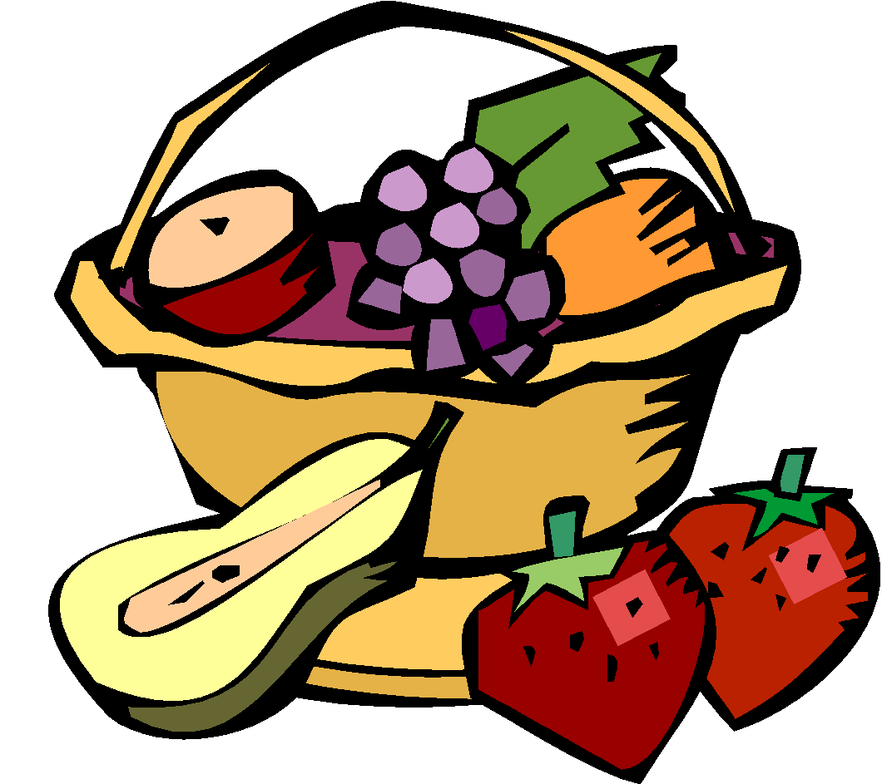

Class Parties

I will send an email to sign up for party supplies, as I am not sure yet what the plan is for Curriculum Night. I will send a reminder to you the week prior to the party if you have signed up to donate something.

Schedule-Pending

Recess

Lunch

Specials

Monday – Music Tuesday – PE Wednesday – PE

Thursday – PE Friday - Art and Library

I suggest sneakers for the first day in case we have Gym!

